**CMPE 207 : Network Programming and Applications**

**Homework 1: Simple TCP Client**

**Submitted by Team Network Ninjas (Shashank Bheemanapalli, Vidhatri Milind Joshi and Sahiti Shankar Varada)**

1. Network Client Application to connect visa tcp (port 23) to:

2a02:898:17:8000::42

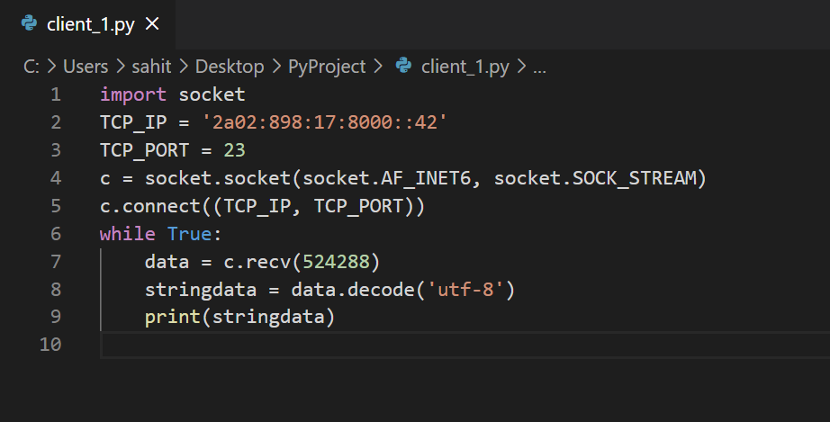

1. Network Client Application to connect visa tcp (port 23) to:

94.142.241.111

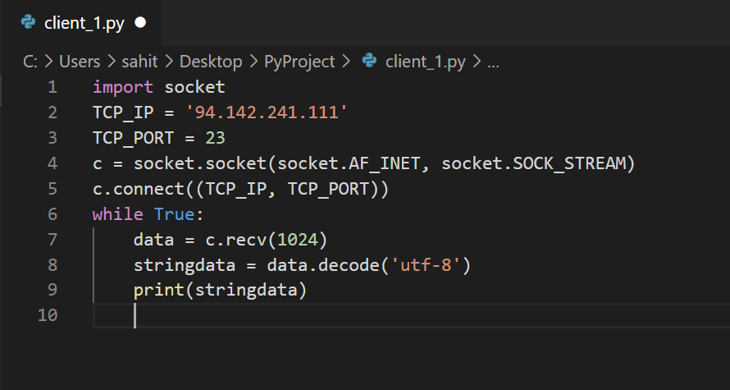

1. Since the server is down, the client is unable to connect to the server.

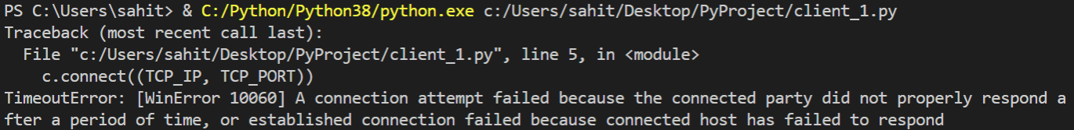

P.S: The same code was executed a month ago. The server was up and were able to access the file. Unfortunately, the output was not recorded. At the time of making this report the server is down, thus output was not captured.